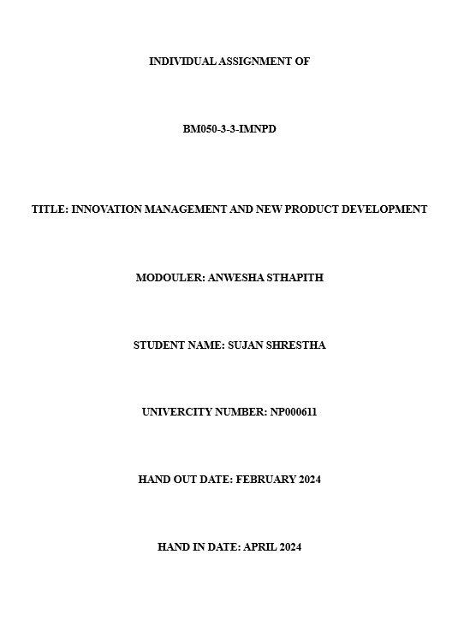

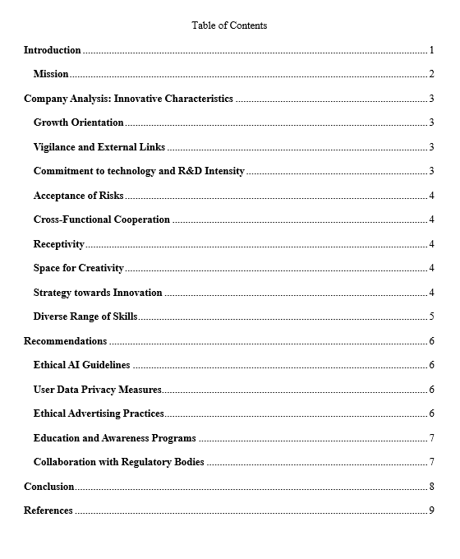

# **Introduction**

Google LLC, a giant in global technology well known for its new and innovative technologies and services. Google LLC is a multinational company based in America which focuses on various services such as search engines, Digital Advertisements, cloud and networking, quantum computing, commercial software, AI, and other technological aspects (Stephanie, 2019). Due to its domination in the market, data collection abilities and technological advancements in different fields, it is named among the most valuable companies in the world according to different magazines and newspaper (McCormick, 2016).

Co-founded on September 4, 1998 through Sergey Bin and Larry Page, the company went public through initial public offering (IPO) in 2004. Google was further reorganized as a wholly owned subsidiary and a holding company for Alphabet company (Feiner, 2019). The company has further grown towards every technical aspect with different online services and applications as its offerings where two of the world's most visited websites are from this company which are Google and YouTube. Google has put itself into many other ventures as well from internet services and consumer electronics such as quantum computing, self-driving cars, smart cities and many other ventures. Due to all these grasping services in technology, google has secured itself a second position on the list of most valuable brands according to Forbes and secured a fourth position according to Interbrand (Swant, 2019).

## **Mission**

According to the Google LLC itself, “Google’s mission is to organize the world’s information and make it universally accessible and useful”. The company was to allow access to useful information around the globe with few finger touches to the screen through the internet. The company dedicated itself towards creating or developing innovative technologies which allow seamless transfer and encourage creativity, empower people, and bring positive change in the world. The company is committed to provides technologies to explore to many angles through which the distance between information, people can be reduced and form better understanding of world for everyone.

# **Company Analysis: Innovative Characteristics**

## **Growth Orientation**

Google LLC demonstrates constant product development and diversification into other technology areas, showing a very strong growth-oriented mindset. The company keeps on continuing the continuous product development and expansion of the company into new sectors. The way of evolving into a multi service and product development company from a search engine such as google maps, YouTube, and create innovative products such as a self-driving car demonstrates the company’s commitment towards growth.

## **Vigilance and External Links**

Google is well known for interacting with its customers through services like search engines and other online and digital advertisements. The company sustains through external links and connections via alliances, joint ventures, and procurements to stay on top of technological advancements. It keeps its eyes open towards any advancing companies in order to grow along with them in their own technological advancements through acquisition, ventures or partnerships.

## **Commitment to technology and R&D Intensity**

The advancements made by Google LLC in the field of machine learning, AI, quantum computing and other computing fields demonstrate Google’s commitment to Technology along with Research and Development (R&D). These advancements lead to the development of products such as pixel, google home and so on.

## **Acceptance of Risks**

Google embraces risk by sponsoring ambitious projects such as Waymo, Project Loon, and Google Glass. The company's willingness to explore new territory and test out novel ideas demonstrates its risk aversion.

## **Cross-Functional Cooperation**

Google makes it easier and quicker to communicate across multiple teams that manage hardware, cloud services, advertising, and search. This cross-functional collaborative operation highlights Google's integrated strategy, ensuring a uniform user experience across a diverse set of products.

## **Receptivity**

Google continues to listen to requests from users and development of market. The company's ability to adapt and respond to frequently changing client preferences and industry trends is demonstrated by periodic updates to its algorithms and user interfaces.

## **Space for Creativity**

Google's "20% time" policy permits staff members to devote a certain percentage of their working time to personal projects, it is an great example of the company's dedication and motive to promote a creative environment. This philosophy fosters creativity and invention, which results in products and technology that are successful, such as Gmail, YouTube and so on (Thi, 2023).

## **Strategy towards Innovation**

Google's innovation approach is heavily stiped on finding solutions to global concerns, user-centric design, and state-of-the-art technology developments. Investments in renewable energy and new field projects like Google X and Brain shows a deliberate and determined commitment to pushing the frontiers of innovation.

## **Diverse Range of Skills**

Google develops multidisciplinary and productive teams with experts from various industries because it values diversity and inclusivity in the working environment. By bringing together all of the varieties of viewpoints to the creation and dissemination of content, this diversity expands Google's potential for innovation (Sitti, 2016).

# **Recommendations**

## **Ethical AI Guidelines**

Google ought to provide and present clear moral standards for AI research, guaranteeing open environment in the selection procedures and tackling prejudices. This is very important because of Google's substantial influence in AI, which calls for a responsible and open approach. It's important to have explicit ethical standards in order to handle the difficulties of AI. In addition to fostering trust of user, transparency guarantees the ethical advancement of AI technology by addressing issues with biases and ethical ramifications.

## **User Data Privacy Measures**

Google should put more safeguards and implement much stronger safety measures in place to ensure the security and privacy of user data, putting in a strict guideline to stop the misuse and other illegal activities. This is important in order to preserve user trust, which is essential to Google's success. Considering Google's massive user data collection, improved privacy protections are needed. Improved security measures can preserve Google's commitment to protecting user privacy and fostering trust in addition to protecting user information and critical data.

## **Ethical Advertising Practices**

Provide and enforce moral advertising guidelines across all Google platforms to make sure that they are consistent and lying under the company's values and to prevent the promotion of harmful or misleading items. Ensuring the integrity of Google's platforms necessitates ethical advertising practices. Advertisements that comply with Google's policies highlight the company's commitment to ethical advertising and user welfare.

## **Education and Awareness Programs**

Create programs and training events to teach staff and users digital literacy, increasing awareness of the moral implications of new technologies and the importance of responsible technology usability. Google's goal of providing global access to knowledge aligns with educational initiatives. Encouraging ethical consciousness and digital literacy ensures responsible technology use that benefits society.

## **Collaboration with Regulatory Bodies**

Engage in proactive interaction with lawmakers in order to build ethical frameworks for new technologies and put collaborative effort with regulatory bodies to ensure adherence to ethical standards and data protection legislation. Google's engagement with regulatory agencies demonstrates its commitment to ethical business activity. Active participation enhances the company's reputation as a responsible global citizen and contributes to the development of ethical frameworks for technology.

# **Conclusion**

In conclusion, Google is positioned as a global leader in innovation due to characteristics such as growth orientation, technological commitment, and risk acceptance. The company's commitment to creativity, timeliness, and cross-functional collaboration demonstrates its influence. Maintaining moral standards in research and product development is critical to Google's capacity to continue to have a good societal effect and maintain their long-term effective vision of changing and evolving more technological areas and sectors in global market.

# **References**

Feiner. (2019, December 3). *Larry Page steps down as CEO of Alphabet, Sundar Pichai to take over*. Retrieved March 8, 2024, from CNBC: https://www.cnbc.com/2019/12/03/larry-page-steps-down-as-ceo-of-alphabet.html

McCormick. (2016, June 2). There's only one AI company that worries me. Retrieved March 8, 2024, from https://www.theverge.com/2016/6/2/11837566/elon-musk-one-ai-company-that-worries-me

Sitti, R. (2016). The Ins and Outs of Google Inc. *A Strategic Analysis*. doi:http://dx.doi.org/10.13140/RG.2.1.3630.3129

Stephanie. (2019, May 7). Google I/O. *From 'AI first' to AI working for everyone*. Retrieved March 8, 2024, from https://www.zdnet.com/article/google-io-from-ai-first-to-ai-working-for-everyone/

Swant. (2019). *The World's Valuable Brands*. Retrieved March 8, 2024, from Forbes: https://www.forbes.com/the-worlds-most-valuable-brands/

Thi, T. (2023). UMAN RESOURCE MANAGEMENT AND ORGANISATION BEHAVIOUR BY APPLYING THE MCKINSEY 7S FRAMEWORK. *THE CASE STUDY OF GOOGLE LLC AND MICROSOFT CORPORATION*. doi:http://dx.doi.org/10.51316/icpt.hust.2023.51